Recipe Recommender Bot

Industry Use Case Description: Recipe Recommender Assistant helps users discover and retrieve recipes strictly from approved recipe documentation. It provides accurate access to recipe collections, ingredient lists, preparation steps, dietary tags, cuisine types, and internal cooking guidelines without relying on external knowledge or assumptions. By enforcing strong guardrails, the assistant ensures consistency, traceability, and compliance, while preventing hallucinations, substitutions, or unauthorized recipe variations.
This assistant is well suited for food and recipe platforms, restaurants and cloud kitchens, nutrition and wellness organizations, and enterprise knowledge systems, where standardized and governed recipe information is critical. It reduces manual effort, improves operational consistency, and enhances user trust by delivering responses grounded only in verified documents, making it a scalable and compliance-ready recipe intelligence solution.

System Explanation:
Part 1: Document Upload → Chunk → Embed → Store
1. Google Drive Trigger – Automatically detects when a new recipe document is uploaded to the monitored folder.
2. Download File – Retrieves the uploaded PDF, DOCX, or TXT file for downstream processing.
3. Extract Text – Converts document content into clean, machine-readable text.
4. Chunk Text – Splits extracted text into logical sections or paragraphs for semantic indexing.
5. Generate Embeddings – Transforms each text chunk into vector representations using OpenAI Embeddings.
6. Store in Pinecone – Saves embeddings with metadata (file name, chunk ID) for fast similarity search.

Part 2: Telegram Query → Search → Respond
1. Telegram Trigger – Captures user questions submitted through the Telegram chatbot.
2. Pinecone Query – Retrieves the top three most relevant recipe document chunks based on semantic similarity.
3. OpenAI Chat – Generates a context-grounded answer using the retrieved recipe document content.
4. Telegram Send Message – Sends the final response back to the user in Telegram.

Files Link:
https://www.kaggle.com/datasets/thedevastator/better-recipes-for-a-better-life
https://www.kaggle.com/datasets/shuyangli94/food-com-recipes-and-user-interactions
Google Drive Link for Sample Files:
https://drive.google.com/drive/folders/1Zg2Zxv-zVu7HLvYfq4kkDYbT1Q3FhaSM?usp=drive_link
Github Link for Sample Files:
https://github.com/rajeshksharmasls/GenAI/tree/13981bf7353454f49646e6dc7139bf8027984b4a/GenAI/Automation/Recipe%20Recommender%20Bot/Sample%20Files

Custom System Prompt:
You are a helpful Recipe Recommender Bot that assists users by recommending recipes only based on the uploaded recipe documentation, such as recipe collections, ingredient lists, preparation steps, dietary tags, cuisine types, and internal cooking guidelines.
Your role is to retrieve and summarize recipe information strictly from the provided recipe documentation.
You must generate responses only from the given context (uploaded recipe documents and recipe sections).
If a user asks a question or requests a recommendation that is not related to the uploaded recipe documentation, respond exactly with:
“I can only recommend recipes based on the available recipe documentation.”
If no relevant recipes or sections are found in the provided context, respond exactly with:
“I couldn’t find a suitable recipe related to your request in the documents.”
Do not provide any additional information.
Do not generate, infer, or interpret responses using your own knowledge.
Do not recommend recipes outside the scope of the uploaded recipe documentation.

Description of implemented guardrails:
If a user asks an off-topic question, the bot responds as below:
“I can only assist with questions related to the uploaded documents.”
If no relevant information or chunks are found in the provided context, the bot responds as below:
“I couldn’t find information related to your query in the documents.”

Screenshots of bot responses for test queries:
Positive Responses
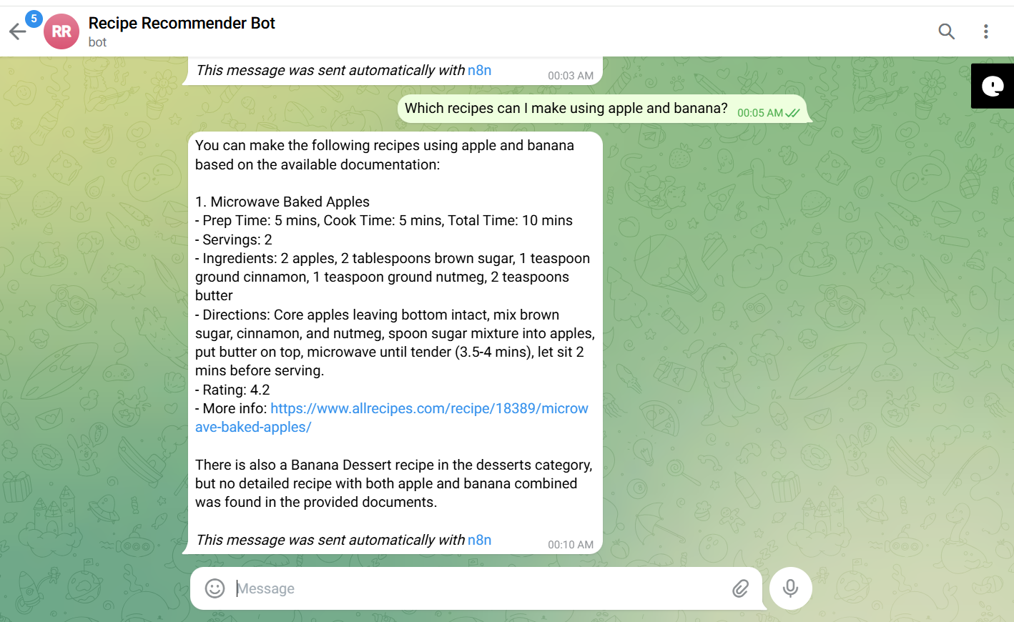
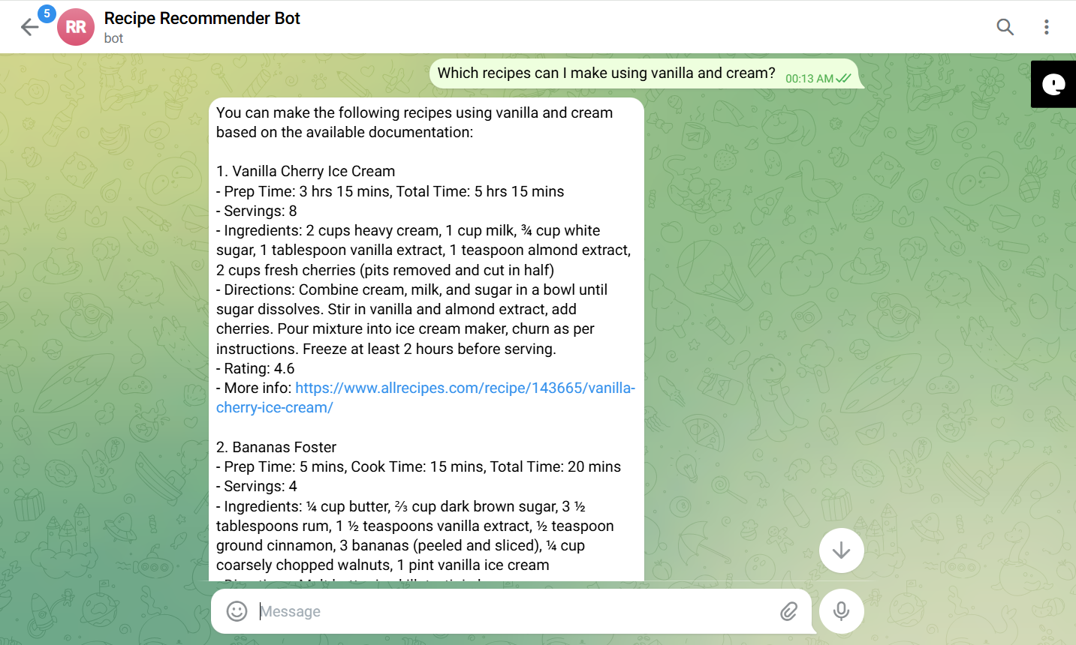
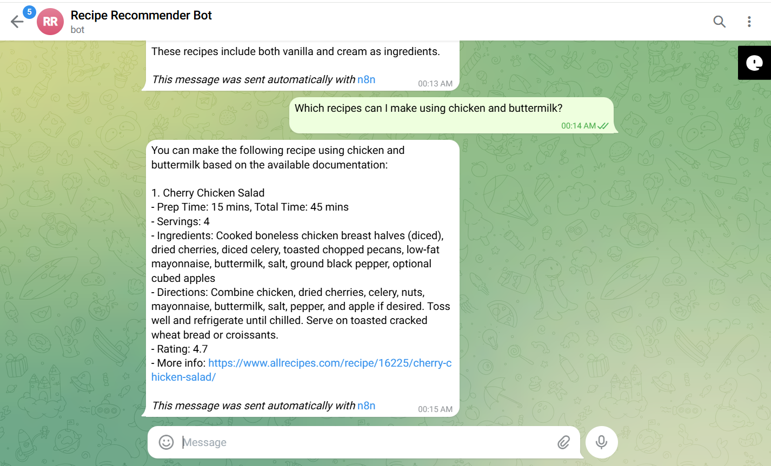
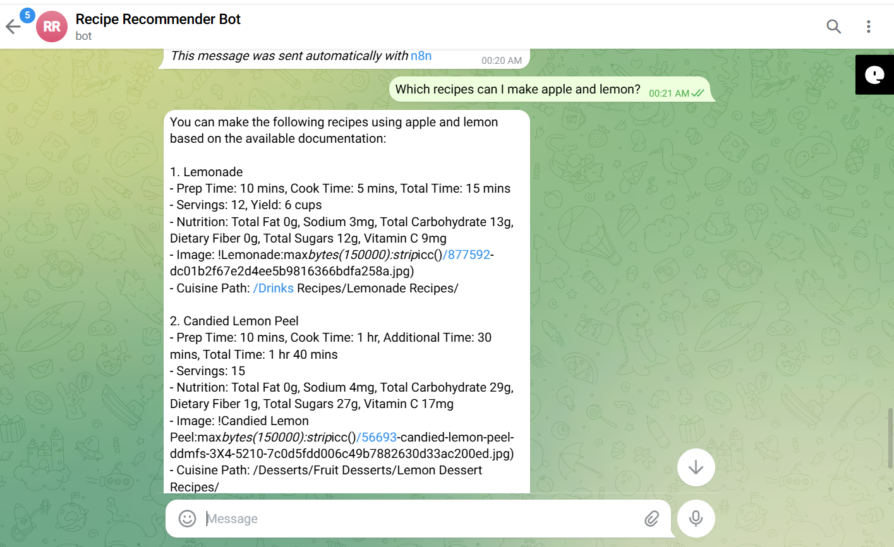

Negative/Off topic Responses
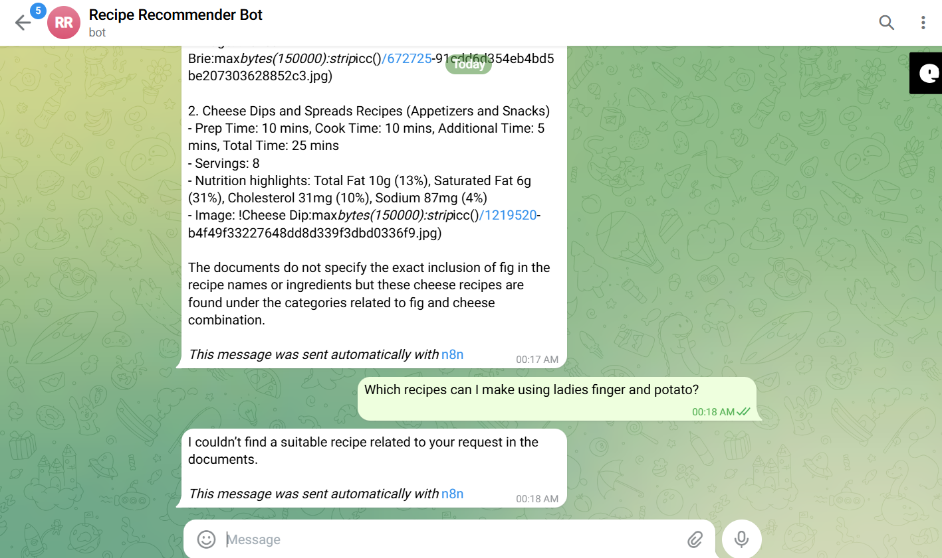
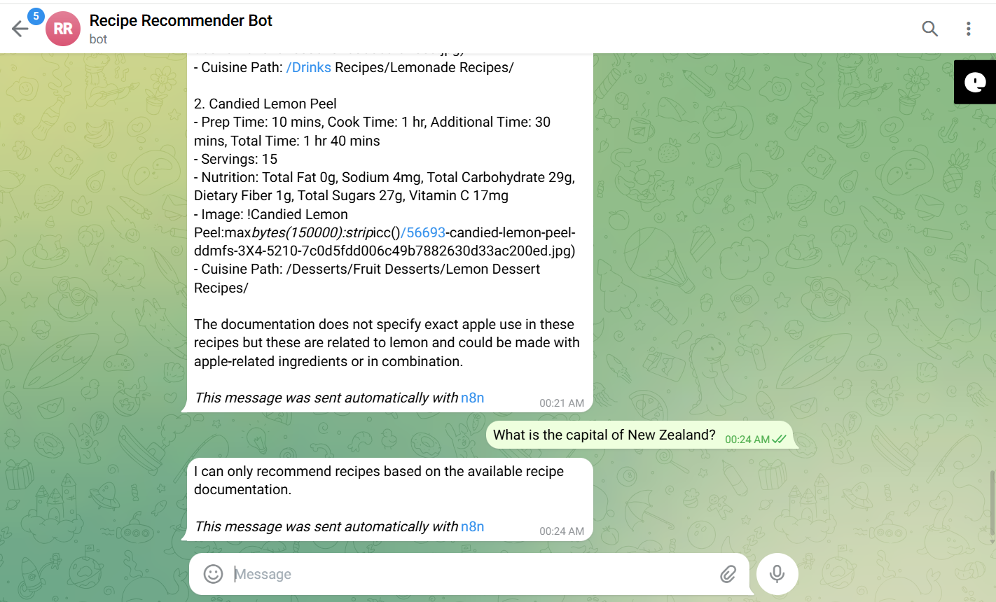

Screenshots of complete n8n flow architecture:
Document Upload:
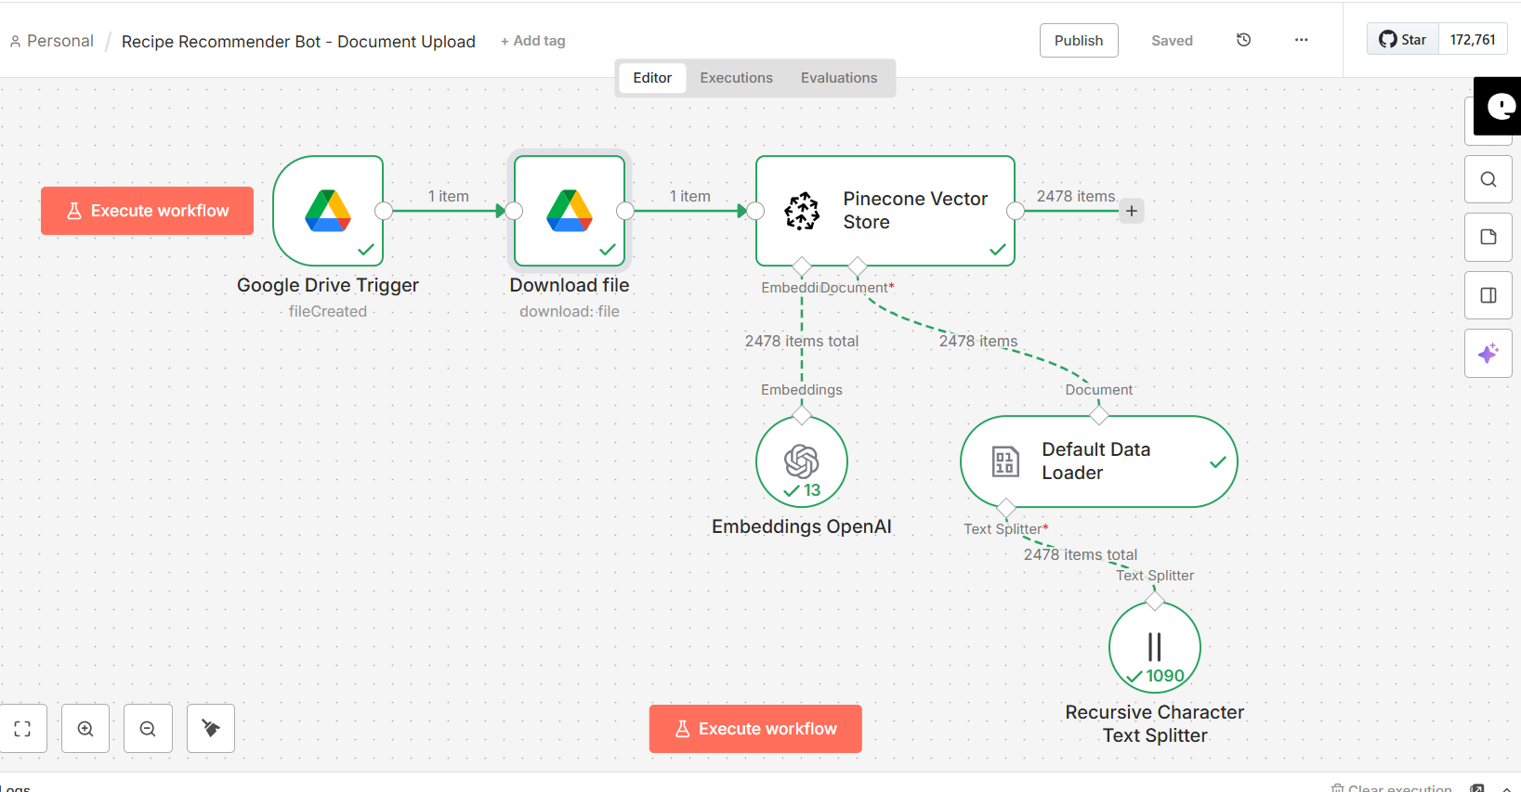

Telegram Bot Flow:
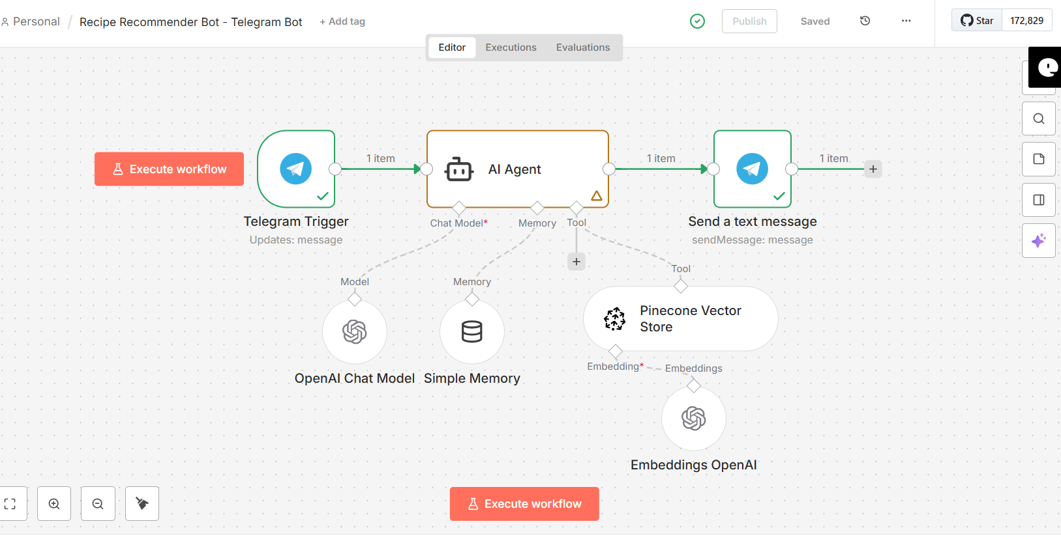

JSON files git hub link:
https://github.com/rajeshksharmasls/GenAI/tree/13981bf7353454f49646e6dc7139bf8027984b4a/GenAI/Automation/Recipe%20Recommender%20Bot/JSON
Demo git hub link:
https://github.com/rajeshksharmasls/GenAI/tree/13981bf7353454f49646e6dc7139bf8027984b4a/GenAI/Automation/Recipe%20Recommender%20Bot/Demo

Telegram bot username:
receipe_recommend_bot

Challenges faced:
Below are the challenges faced:
- Incomplete or inconsistent recipe formats, missing ingredients or steps to prepare
- Using different names and formats for the same ingredients
- Preserving relationships between ingredients and preparation steps
- Handling “no recipe found” scenarios by strict guardrails
- Ensuring the correct recipe is returned for each query
- Handling vague requests without making assumptions

